**Olympic Dataset Analysis**

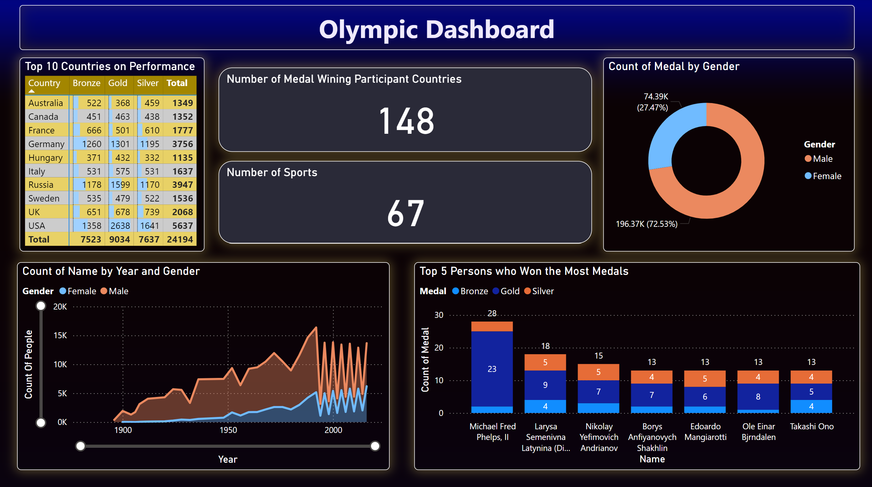

**Problem Statements:**

Analyze the dataset and review the following problem statements.

1. **Medals Won by Gender%**

2. **Male and Female Ratios by Year**

3. **Top 10 Countries by Medals**

4. **Top Olympic Medalists by Total Medals**

5. **Total Number of Participating Countries**

6. **Total Number of Sports**

**Solutions:**

1. **Medals Won by Gender%**

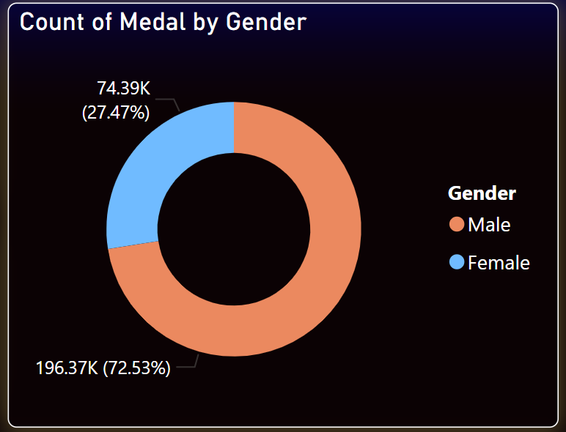

2. **Male and Female Ratios by Year**

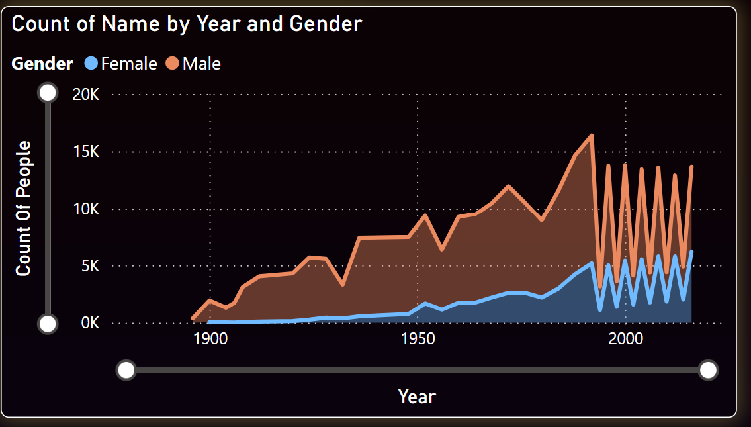

3. **Top 5 Countries by Medals**

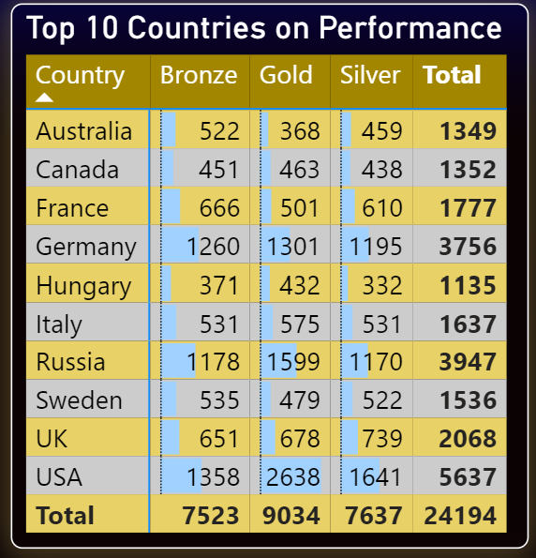

4. **Top Olympic Medalists by Total Medals**

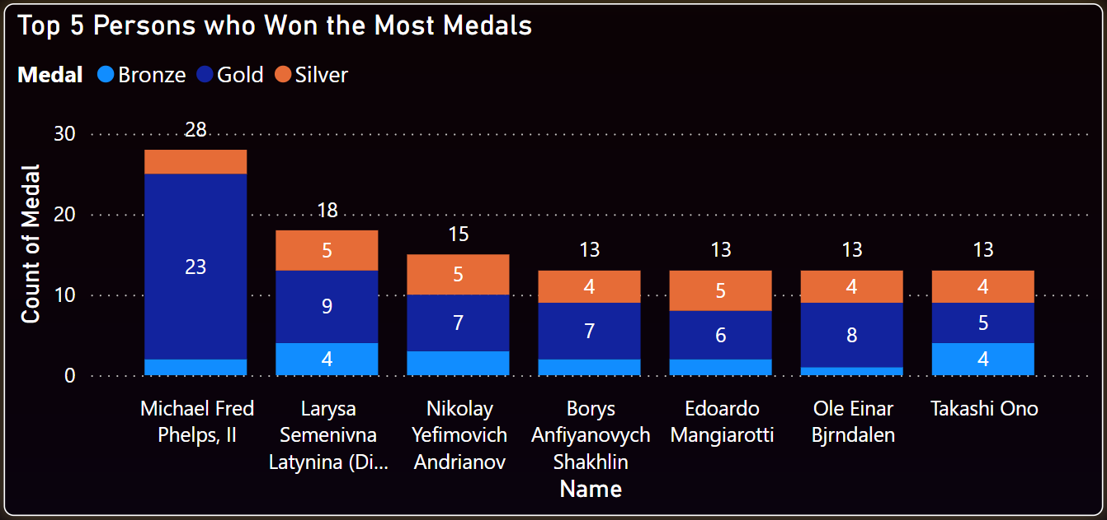

5. **Total Number of Medal Winning Participating Countries**



6. **Total Number of Sports**



**Link to the GitHub Repository**: <https://github.com/hrishinthecoder/Olympic-Dashboard-PowerBI->

**Link to the PowerBI Report:** <https://app.powerbi.com/links/cBPsV0G4r0?ctid=6ef33993-a22d-4072-84ca-afc10ca48665&pbi_source=linkShare>